

User Documentation

This document contains detailed instructions guiding each user

through the application and its different functions.

Contents

1. Contributor ──────────────────────── 1

Forecasting Task ───────────────────── 1, 2

Upload File Sets ───────────────────── 1, 2

File Metadata ────────────────────── 2

2. Participant ──────────────────────── 3

Download File Sets ──────────────────── 3

Forecasting Task ──────────────────── 3

Upload Solution File ──────────────────── 3

3. Administrator ─────────────────────── 4

Login ────────────────────────── 4

Database Management ────────────────── 4

5. Additional Notes and Clarifications ───────────── 5

1. Contributor

A contributor is a user who uploads time series data to the database, split into two sets: the test set and the training set. This user also fills out the forecasting task form with data relating to the uploaded files.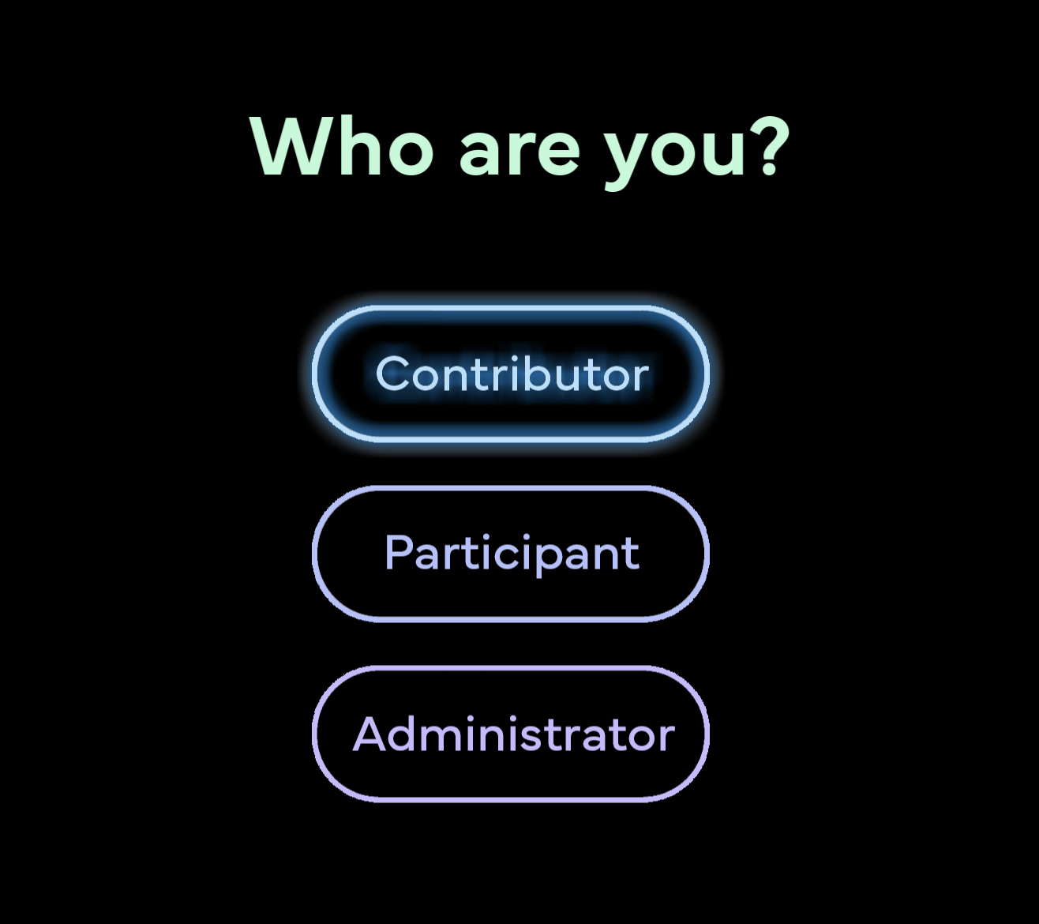

From the homepage, in order to enter the contributor page where the user may upload data, the user may choose the “Contributor” button. All of the fields displayed on the contributor page must be filled out in order to submit any data.

Upon entering the contributor page, the user will see this form. The Forecasting Task region is where the user may name or describe the context of the test and training sets they want to upload in the Task description field. In this region the user will also fill out the Period and Number of forecasts according to their data. The number of forecasts represents the number of periods a participant user will forecast.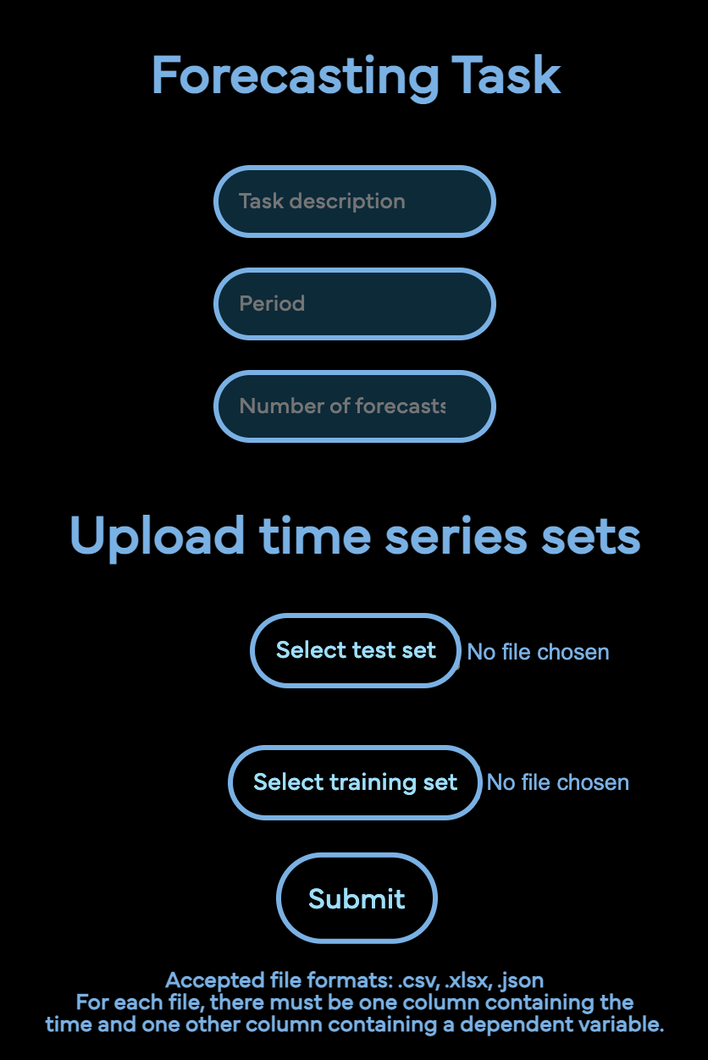

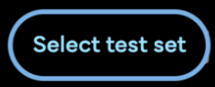 In the Upload time series sets region, the user will select the “Select test set” button to select the desired time series files from the user’s local files on their computer to include in the uploaded test set. This button will make a new box appear, allowing the user to select local files. Only .xlsx, .json, and .csv files are accepted by the application, and multiple training files may be selected at a time. To select more than one file, the user may Ctrl+click additional files, or Shift+click to select an area of files. The user will 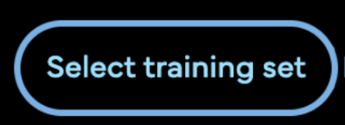complete the same process for the training set with the “Select training set” button. Finally, the user will “Submit” all inputs at the bottom.

Here is a short looping demonstration of how a contributor user may use the application to upload time series data for a task called “North and south fish.”



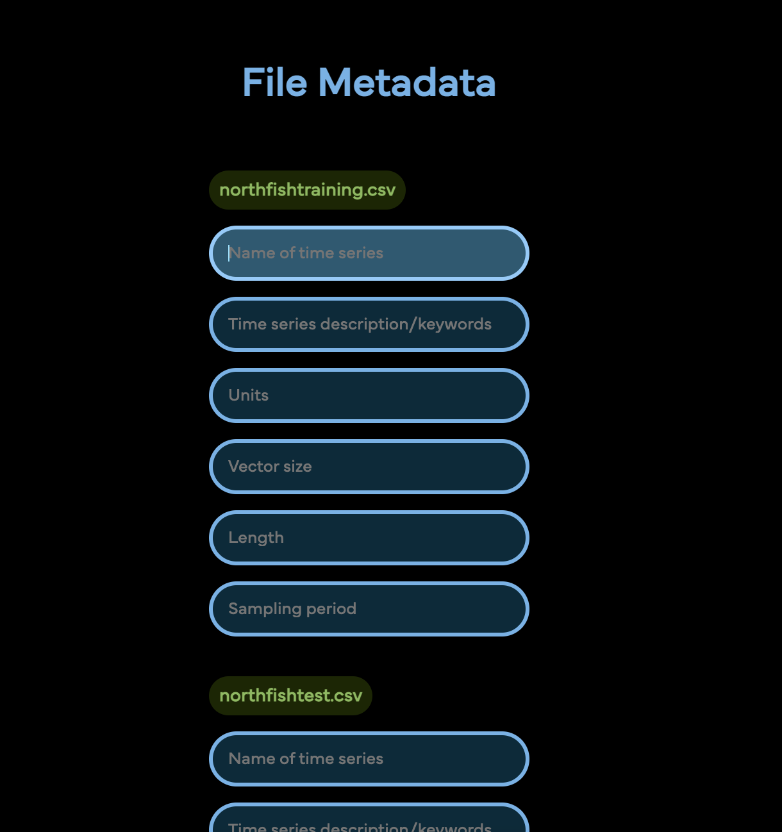

Upon submission, the user will be directed to the file metadata webpage where the user will fill out metadata for each file they uploaded. The color-changing titles above the form blocks indicate to the user which file each series of fields corresponds to. All fields are required. Name, description, and units are string or text fields, while vector size and length are integer or whole number fields, and sampling period is a float or decimal number field. Once all fields have been filled out, the user may submit the metadata form with the “Submit” button at the bottom of the page.

2. Participant

A participant is a user who downloads sets of files that have been already uploaded by a contributor. The participant may then upload their solution data to the database and then view a variety of metrics that compare the contributor and participant data.

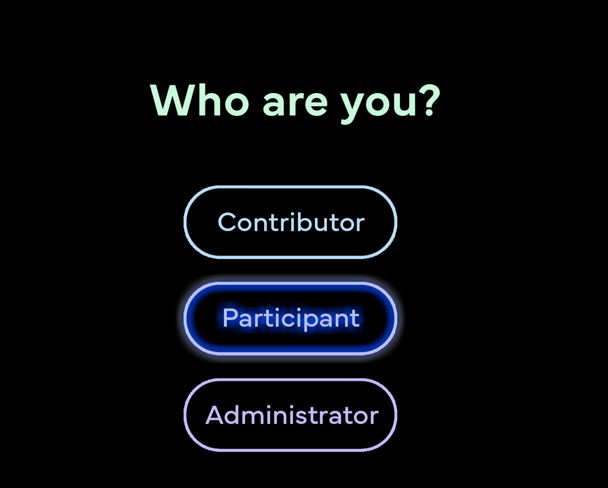

From the homepage, in order to enter the participant page where the user may begin downloading data, the user may choose the “Participant” button.

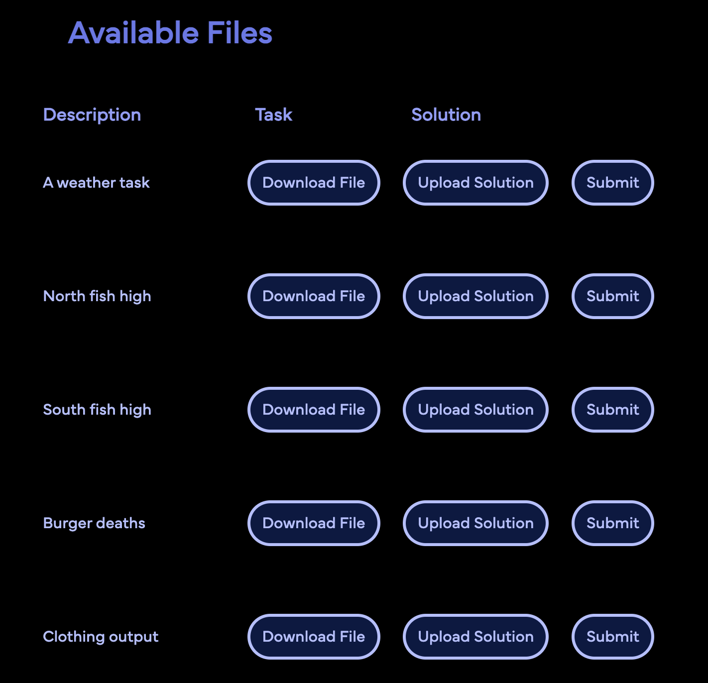 Upon entering the participant page, the user will see this view of all the tasks available for download. If there are many 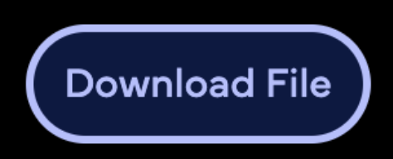tasks available, the user may scroll down to view them all. The user may click the “Download File” button corresponding with the desired task, then click “Save” to download a .zip file to their computer. This .zip file will contain the test and training sets associated with the chosen task, in the original file format. The .zip file will also contain a folder containing an image graphing the comparison and a .json file

with comparison metrics using random data in place of data uploaded by a participant user. If the participant has a solution set to upload for one of the listed tasks, they may click on the “Upload Solution” button next to that task and select a file to upload. Once a file has been chosen from the file selection window, clicking on “Submit” on the same row as the desired task will submit the uploaded solution to the database.

3. Administrator

An administrator is a user who may view the entire database in detail and also make changes to the data uploaded by contributor and participant users. 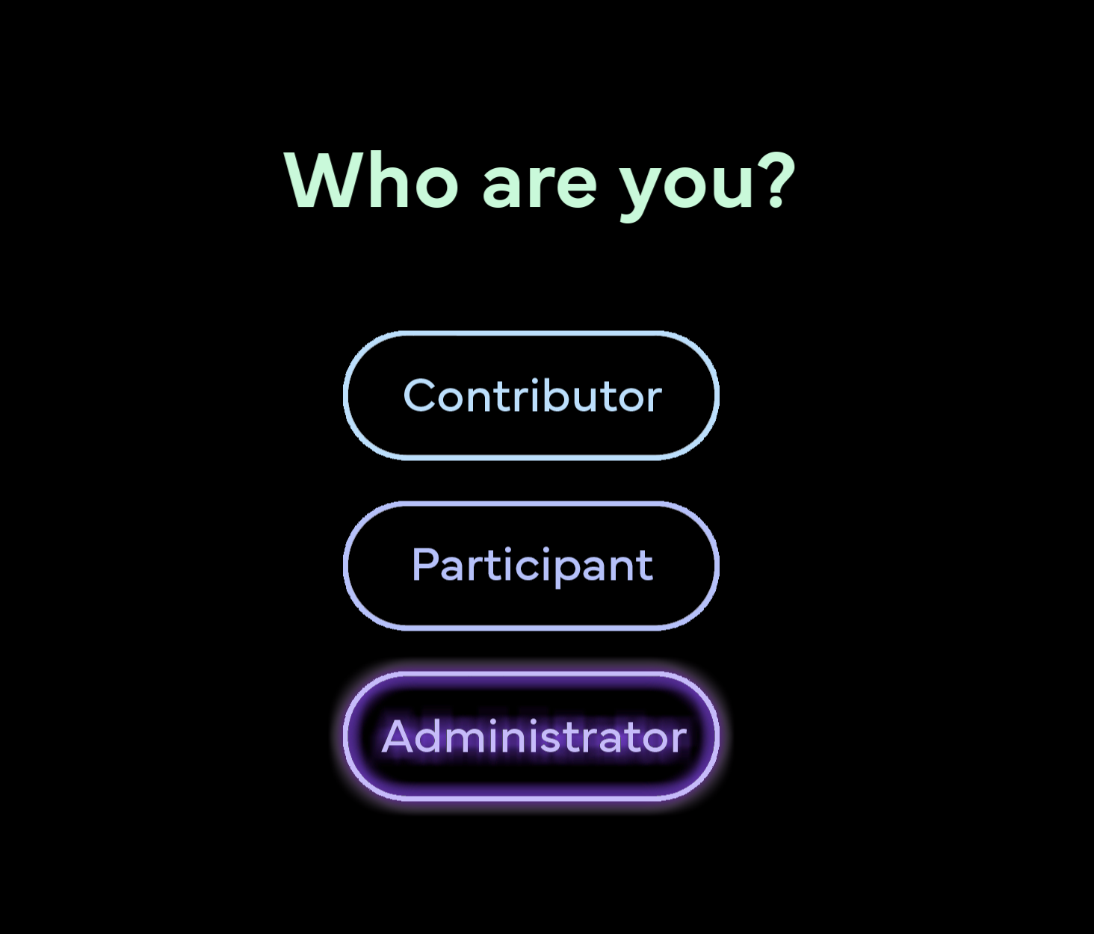

From the homepage, in order to enter the administrator page, the user may choose the

“Administrator” button. Upon clicking this button, the user will continue to the Login page where the user may log in to an existing superuser, or admin account. If the user wishes to create a new account, they may run the following command from the command line on their computer from the Django/mysite

directory without the app running:

While running, they may follow the Username, Password, Password (again), and 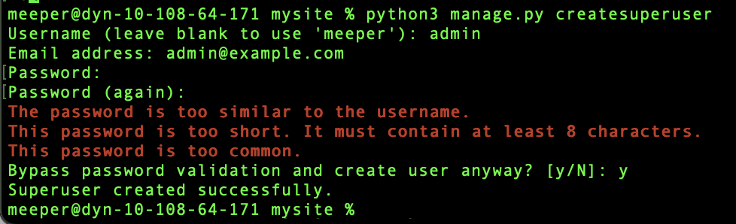optionally Bypass password prompts to create the superuser with the desired account details. Here is an image demonstration of the superuser

account creation process.

The user’s existing account information may be entered into 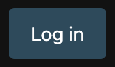the administrator login page and

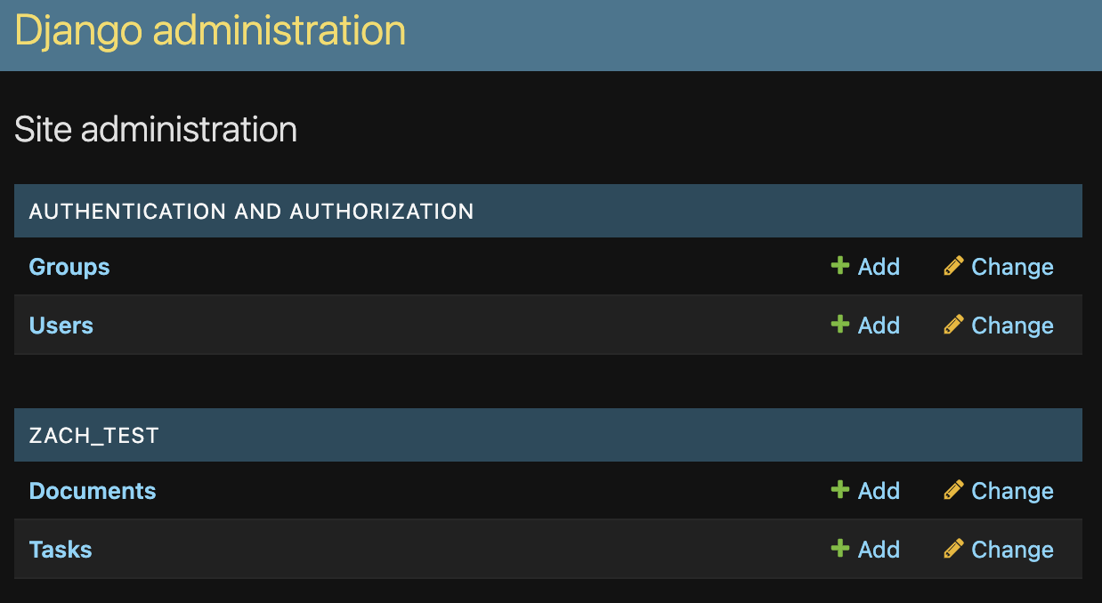pressing “Log in” will log the

user in and show the Django administrator dashboard.

The data that can be managed or viewed by the user is sorted into “AUTHENTICATION AND AUTHORIZATION” and “ZACH_TEST.” To manage registered superusers, click on “Users” under “AUTHENTICATION AND AUTHORIZATION.”

To manage files in the database, click on “Documents” under “ZACH_TEST.”

To manage forecasting tasks in the database, click on “Tasks” under “ZACH_TEST.” The user may sign out of the admin account by clicking “LOG OUT” in the top right corner of the webpage.

4. Additional Notes and Clarifications

* See the installation instructions for full details on installing and running the application.
* Any user may navigate back to the homepage while the application is running by going to the following URL: <http://127.0.0.1:8000/home/>
* Only .csv, .json, and .xlsx files are accepted while using the application.
* For each task, multiple files may be selected for the training set, but only one file is allowed for the test set, and only one solution file per task may be uploaded.
* All fields are required for each form.
* Solution data uploaded by the participant will not be factored into comparison metrics. Only the randomized fake participant data is compared against the real contributor data for comparison metrics.